Embedded Systems Project

Arduino Based Auto Irrigation System

Project Proposal

|  |  |
| --- | --- |
| Name: Aryan Pastagia | Roll no: A227 |
| Sap: 70012100201 | Branch : B Tech IT 3rd Year Batch : A |

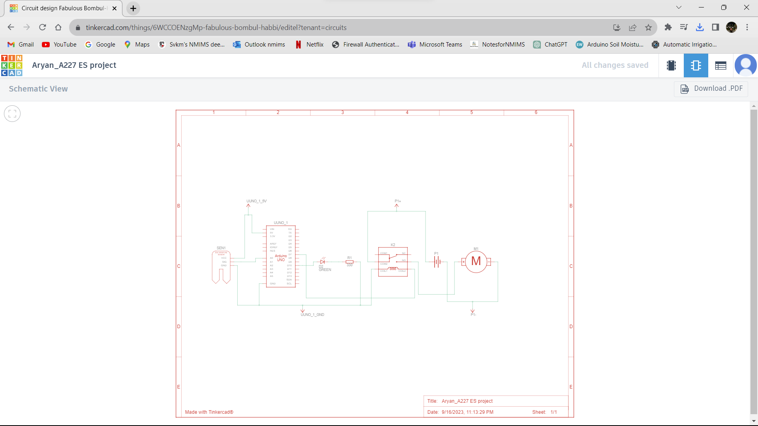

Project Overview

Project Title: Arduino-Based Auto Irrigation System

Project Team: Aryan Pastagia

Project Supervisor/Mentor: Professor Mayank Kothari Sir

Project description

Introduction

Water is a precious resource, and efficient irrigation systems are crucial for conserving it while ensuring optimal plant growth. This project aims to develop an Arduino-based auto irrigation system that can monitor soil moisture levels and control the irrigation of plants accordingly. The system will provide an automated and efficient solution for managing water resources in small scale agriculture and gardening.

Objectives

* Design and build a reliable and cost-effective Arduino-based auto irrigation system.
* Implement soil moisture sensing to determine when and how much to irrigate.
* Integrate weather data to adapt irrigation schedules based on weather conditions.
* Optimize power consumption to ensure long-term operation with minimal maintenance.

Project Components

The project will consist of the following key components:

* Arduino Microcontroller: The brain of the system responsible for processing data and controlling irrigation equipment
* Soil Moisture Sensors: Sensors placed in the soil to measure moisture levels.
* LED : To indicate whether the pump is on or off.
* Resistor: To control the flow of current .
* Water Pump: A water pump to deliver water to the plants.
* Weather Data Interface: Integration with a weather data source (e.g., online API) to access real-time weather information.
* Relay
* Power Supply

Methodology:

Software Development:

* Create a graphical user interface (GUI) using Tinkercad.
* Write Arduino code to control the hardware components.
* Implement a scheduling algorithm for irrigation cycles.
* Integrate real-time weather data to optimize irrigation.
* Develop error handling and notification features.

Simulation and Testing:

* Simulate the entire system on Tinker cad to validate functionality.
* Test the system with various scenarios (e.g., different soil types, plant types, weather conditions).
* Fine-tune the software algorithms based on test results.

Conclusion:

The Automated Irrigation System project using Arduino and Tinker cad aims to provide an efficient and sustainable solution for managing water resources in agriculture and gardening. This project will not only conserve water but also increase crop yield and promote responsible water usage. Additionally, the Tinker cad simulation will allow for easy testing and validation of the system's functionality before physical implementation.